NATIONAL INSTITUTE OF TECHNOLOGY
TIRUCHIRAPPALLI

Department of Computer Application
FARMER’S BUDDY
Project Work
Submitted By :
UTSAV OJHA - 205119107
Under the Guidance of
Dr. U. Vignesh

CERTIFICATE
This is to certify that the Project Report entitled “FARMERS BUDDY” is a record work carried out by UTSAV OJHA (205119107) under my guidance and supervision in partial fulfillment of the requirements for award of the degree of MASTER OF COMPUTER APPLICATION

External Examiner
ACKNOWLEDGEMENT

We take this opportunity to thank all those magnanimous persons who rendered their full services to our work.

It’s with lot of happiness we are expressing gratitude to our guide DR. U. Vignesh for timely and kind help, guidance and for providing us with most essential materials required for the completion of the completion of this project. We are very thankful to her for his indomitable guidance. This inspiration up to the last moment had made things possible in a nice manner.

Table of contents

- Abstract..……………………………………………………………........01
- Glossary...………………………………………………………..………02
- Introduction………………………………………………………...........03
  - About Project
- Project Analysis…………………………………………………………. 04
  - Purpose of the Project………………………………………………… 04
  - Existing system………………………………………………………… 04
    - Problem in Existing System…………………………………........... 04
  - Proposed System……………………………………………………… 05
- Requirement Analysis .……………………………….………….…........ 06
  - Purpose and Scope…………………………………………………….. 06
  - Users of the System…………………………………………………… 06
- Specific Requirements………………………………………………….. 07
  - Functional and Non- Functional Requirements…………....................... 07
  - User Interface Requirements……………………………………….…...08
  - Proposed System Architecture………………………………..………....ss08
- System Requirements………………………………………….………….09
  - Technologies Used……………………………………………………....09
  - Tools Used…………………………………………………………..…..14
- System Design ………………………………………….…………….......19
  - Data Flow Diagrams…………………………………………………….19
    - E- R Diagrams……………………………………………………...19
  - Behavioral Diagrams ……………………………………………………20
    - Use Case Diagrams………………………………………………….20
    - Class Diagrams……………………………………………………...23
    - Collaboration Diagrams…………………………………………….24
    - Sequence Diagrams…………………………………………………27
    - Activity Diagrams……………………………………………….32
  - System Specific Modules …………………………………..……..36
  - System Evolution …………………………………...……..……….38
  - Screens ……………………………………………………...……...38
  - Testing ……………………………………………………...……...50
  - Appendix A - Hardware and Software Configurations……..........51
  - Appendix B – Data Base Tables ………………………….………51
  - Limitations and Enhancements …………………….…………..…53
  - Bibliography ………………………………………….…………..54

1. Introduction

1.1 About Project:

This is a web based project which is useful for farmers and agricultural students. This is an open discussion portal providing solutions to small farmers and agricultural students. It also provides soil analysis for all regions and suggestions on which fertilizers to use where and how much? And which crop, herb or vegetable to be grown where and in which season? It also helps to make decisions on market and best prices. Information about major crop markets and their current price for the crop will be published daily. NGO’s are trying to spread messages to make agriculture more eco-friendly through this site. This also includes training scheduled by agricultural officers. Training is requested by students, general public. Training provides information about crops, fertilizers, and market details that are requested. Online query handlings for all users. Queries can be posted by students, general public through mails. Queries can be directed to a particular officer. Information pages should be dynamic so that agricultural officers and administrator can change it.

2. Project Analysis

2.1Purpose of the Project:
It is an open discussion portal used for agricultural students and farmers. Any general public can use this system for knowing the information about various crops, and the usage of fertilizers to those crops and in which soil these crops give more yield and the climatic conditions for those crops.
Training is requested by the students, general public. These trainings are scheduled by agricultural officer. Information about major crop markets and their current price for the crop will be published daily.
Current prices of the markets are updated daily by the NGO. It gives information regarding all the states in India.

2.2 Existing System:
Complexity in managing the data related to the agriculture products, soils, fertilizers, mandi/market details.
2.2.1 Problems in existing system:
- Lack of security.
- This system does not provide category wise classifications of products.
- Inefficiency in querying details.
- Periodic Report generation takes lot of time.

2.3 Proposed system:
The development of this new system contains the following activities, which try to automate the entire process keeping in the view of database integration approach.
- Reduce complexity in managing the data related to the agriculture products, soils, fertilizers, mandi/market details.
- Current system provides different access levels for security.
- Rich user interface is provided in order to interact with application.
- Reports are generated dynamically on a periodic basis.
- Efficiency in querying details.
- User Queries and Answers are maintained.
2.4 Data collection:
Early Spring:
Beets, Broccoli, Brussels Sprouts, Cabbage, Cauliflower, Carrots, Cress, Lettuce, Onions , Peas , Potatoes, Radishes , Salad Greens, Spinach
Summer:
Beans, Butter Beans (Limas), Cantaloupe/Muskmelon, Corn, Cowpeas/Crowder, Cucumbers, Eggplant ,Garlic, Herbs, Okra, Peppers, Pumpkin, Soybeans ,Squash , Sweet Potatoes, Tomatoes, Watermelon
Fall:
Beets, Broccoli, Brussels Sprouts, Cabbage, Carrots, Cauliflower, Cress, Lettuce, Peas, Radish, Salad Greens, Spinach, Turnips
Permanent Crops:
Asparagus, Blackberries, Blueberries, Grapes, Potato, Onions, Rhubarb, Strawberries, Raspberries. Crops such as tomatoes and peppers will drop their blooms and it can even mess up a peppers ability to produce properly. If the leaves of beans get frost-bitten it can stun them and actually slow down their ability to grown properly.
Frost will kill summer plants. If you do get caught with a late freeze you can cover your plants with newspaper, straw, or plastic. Tomatoes can be covered with 5 gallon buckets or grocery bags but even these will not always protect the tender young plants from the cold. Every gardener learns this hard lesson sooner or later. If frost gets on your plants, you must get up before the sun and sprinkle water on your plants to wash off the frost. If the sun hits the frost, it is too late. The frost is a lethal poison to your plants and they will die.
Mulching summer plants, especially ones that produce all summer or are long growing such as cucumbers, squash, okra, tomatoes, potatoes, peppers, cantaloupe, watermelon or pumpkins. Good mulching reduces a lot of labor by helping to conserve moisture and reducing those hateful, nasty weeds. It also makes the garden pretty and in the fall provides humus to be worked into the soil.
Mulching materials:
Straw :
This is an excellent mulching material but the wheat or barley seeds in the straw will sprout and grow. It is best if the straw is allowed to get wet and go through a heat to kill the seeds before using.
Newspaper :
This is a way to recycle your newspaper! It will blow away if not weighted down. Some like to use it under the straw as an additional weed blocker.
Grass Clippings :
These are free for the getting and a way to dispose of that extra grass. Because it is a green clipping you may have to add extra nitrogen to help compensate for the nitrogen it pulls out of the ground.
Weed Blocker or Black Plastic :
Excellent protection but more expensive and has to be removed in the fall. Always use black plastic as it helps to block the sunlight. Be sure to punch holes in the plastic so water can penetrate.
Soil Analysis:
An accurate soil analysis is vital to understanding your soil. We use high quality laboratory analyses that work specifically for our system.
Before sending soil samples to us please check out Taking a Good Soil Sample and Sending Soil Samples to K.A.S.
From the basis of a detailed soil analysis, and plant tissue analysis when necessary, and - importantly - the additional information that you provide by completing the free soil test worksheet, we build a specific fertilizer recommendation for each soil sample, tailoring the recommendations to your particular operation and goals.
The recommendations will utilize the proven principles of the Kinsey/ Albrecht system of soil fertility management. The aim is to correct and raise the overall soil fertility to improve and maintain yields and/or crop quality. If we have previously made recommendations for the same soil location, and it has been properly identified as such, then these previous analyses and recommendations are taken into account also.
Samples originating outside of the U.S. and Canada require specific USDA clearance, and may also have to be priced differently according to the service you require - please contact us for the proper procedures, and information concerning cost of analysis and turn-around time before sending any soil.
Fertilizer Recommendations:
Our recommendation report for each sample has two parts: the soil analysis and recommendation for achieving the proper fertiltiy level.The basic soil analysis will normally include:
Total Exchange Capacity (T.E.C.)
Soil pH
Organic Matter (Humus) as percent
Nitrogen (N released from colloidal humus)
Sulfate (Expressed as elemental sulfur) in ppm
Phosphates (as P205)
Olsen value (Included at no charge if pH is above 7.5)
Percent Base Saturation of:
Calcium, Magnesium, Potassium, Sodium, Other Bases Exchangeable Hydrogen Calcium, Magnesium, Potassium, and Sodium levels - in lbs/acre*
Trace elements:
Boron in ppm
Iron in ppm
Manganese in ppm
Copper in ppm
Zinc in ppm
Our recommendations for a specific plan of fertilizer amendments are tailored to your expressed short or long term goals, and take into account the previous history of crops and fertilizers at the location, farming conditions in the area, your type of operation, fertilizer preferences, and other factors, as supplied by the grower, in addition to the condition of the soil.
We do not sell fertilizers or soil amendments. It is suggested that to the extent possible you work locally to obtain materials from your preferred fertilizer dealership.Since each soil is tested in more detail than is customarily done in various areas, and provided as well with its own specific set of recommendations, some needed materials may not always be stocked by local dealers. This tends to be especially true for those striving to be certified organic growers.
Taking a Good Soil Sample:
The way the soil samples are taken is extremely important, as the recommendations you receive from soil tests will only be as good as the samples you send for analysis.
Following the instructions below will assure that the samples you send are taken in the way we need them for a proper analysis.
When to take a soil sample. Soil samples may be collected at any time of the year, provided that the area is not suffering from prolonged drought, that no nitrogen has been applied in the last 30 days and no sulfur has been used in the last six months.Late spring and early summer sampling avoids the rush, shows the soil's fertility at its best and gives time to plan a soil fertility program which can begin directly following harvest if necessary.
However, if no samples have been taken within the last two years, the best time to sample is as soon as circumstances permit.Generally, sampling should be done every year if fertility is high and / or trace elements are being used to achieve top yield from year to year and is useful at the time of fertilization
Collecting the Sample(s):
The sample bag: Use a new soil-sample container, plastic bag or plastic container.
Soil-sample bags are available free from Kinsey Agricultural Services. Zip-loc bags are fine as long as they have never been used - but put Scotch tape over the writing or attach masking tape to write on because all types of marking ink can rub off the bag during shipment. Do not use paper sacks from the grocery store, bread wrappers, or such items, due to possible contamination. Avoid using a plastic bucket that has been used for other purposes. Even repeated washings of a bucket used to mix salt and minerals for feed can still result in contamination of the sample.
Label the sample bags with your name, the farm name if any, field number and sample area.
Prepare a map or sketch of the area for your own records. Make sure the labeling on the bag matches the number of the field and area on your map. Labeling the bags to match the areas before taking the sample helps.
A SOIL PROBE is recommended for easiest and best sampling results. Using a soil probe or shovel, sample down to a depth of 6½ -7 inches (17cm), or to the depth the soil will be thoroughly mixed when worked if that will be deeper than 6½ -7 inches.For no-till crops,orchards, vineyards, pastures, hay meadows, lawns, etc., where soils will not be worked, the depth should be 4 inches (10cm). Sampling to the proper depth is extremely important ifwe are to provide each grower with the correct recommendations. Put the soil, using several probes from like areas to make up the sample, into the sample bag.
Removal of obvious debris (roots, leaves, etc.) is fine but unnecessary as it will not adversely affect the sample. If you do remove debris from the sample, be careful that none of the actual soil is removed with it.
Probe the soil every 50 to 100 paces, always taking a minimum of 5 probes per composite sample for smaller areas, and one probe for every 1 (one) to 2 (two) acres from larger areas.
Only a small amount of soil is necessary for analysis. A cupful of soil is more than enough.Just be sure your sample represents the entire soil profile, if mixed, in order to send only a small portion. Please remember : this will be a very detailed analysis, which will only be as accurate as the sample you send.
FERTILIZERS:
Nitrogen is a primary nutrient that really makes plants "grow." When you put fertilizer on your lawn, most of the "green-up and grow" comes from the nitrogen.
There are 'quick release' and 'slow release' forms of nitrogen. Slow release forms are more expensive but remain effective for a longer period of time. Organic fertilizers are slow release, and have less potential to "burn" plants.
Nitrogen produces vegetative growth in plants, but too much nitrogen can cause problems. One problem is succulent growth, which makes a plant more susceptible to certain diseases.78% of our atmosphere is nitrogen, and rain and snow account for 2 to 12 pounds of actual nitrogen per acre (43,560 square feet), per year. "Lightning charged rain" is high in NH4 and NO3. Snow has been called "poor man's manure". . . now you know why!
Plants in the Legume family "fix" atmospheric nitrogen into the soil. Peas, beans, clover, and alfalfa are legumes, as well as Black Locust trees.
PHOSPHORUS (P) - the Phosphorus percentage is the middle number on the label
Example: 10-10-10
Phosphorus is a primary nutrient that encourages rooting, blooming and fruit production in plants.
Vegetable gardeners have typically been told to apply 5-10-5 since the higher middle number (P) helps vegetable production.
Phosphorus is important for root-growth and blooming in plants, and is the main ingredient in "starter fertilizers" as well as liquid fertilizer "bloom boosters".Phosphorus is lacking in most Southwestern Pennsylvania soils we have tested since 1979. Applications of super-phosphate 20-0), triple super-phosphate (0-46-0), or bone meal (organic source) can be used to correct deficiencies.
Since phosphorus moves very slowly through the soil, it should be incorporated into the soil prior to, or during planting. In existing lawns, we recommend core-aeration prior to phosphorus application.
POTASSIUM (K) - the Potassium percentage is last on the label
Example: 10-10-10
Potassium helps plants resist disease and aids in winter hardiness.("K" is the symbol for "kalium" or potash, and is commonly used to represent potassium)Most 'winterizer' fertilizers used on lawns in late fall are high in Potassium, since it promotes winter hardiness in turfgrasses.Potassium fertilizers have a high "salt index" and should be used with caution, since they can "burn" plant foliage.Most "complete" fertilizers contain potassium since it is fairly mobile, and readily leaches out of the soil profile.

Secondary Nutrients:
Secondary nutrients also play an important role in plant growth. The 3 secondary nutrients are Calcium (Ca), Magnesium (Mg) and Sulfur (S).
Essential Elements:
The essential elements are basic to plant growth, and need to be mentioned here, even though they aren't commercially available fertilizers. The 3 essential elements are Carbon (C), Hydrogen (H) and Oxygen (O). Plants obtain these elements from carbon dioxide (CO2) and water (H2O).
Macronutrients:
When you group the essential elements with the major nutrients and secondary nutrients, you end up with the 9 macronutrients: Carbon, Hydrogen, Oxygen, Nitrogen, Phosphorus, Potassium, Calcium, Magnesium, and Sulfur: C, H, O, N, P, K Ca, Mg, S
Minor Elements:
Nutrients needed by plants in lesser amounts are known as the minor elements. These include Iron (Fe), Boron (B), Manganese (Mn), Copper (Cu), Chlorine (Cl), Molybdenum (Mo), and Zinc
Information about Soils:
Sandy soil:
All root vegetables like carrots, turnip, beetroot , coconut, cashew also grow.
Herbs:
Chamomile, lavender, thyme, semary, armeria, santolina, saxifrage also grow.In rajasthan soil and vegetation, sugarcane and cotton grows more. Wheat, mustard, maize, fruits, barley available in sandy soil.
Red Soil:
Found in states of AP, Tamilnadu, Orissa, goa, Maharashtra, Karnataka. Red soil has iron content and is fit for crops like redgram, bengalgram, groundnut and castorseed, millets, rice, maize, soyabean, pigeonpea, jute, tea, grapes, banana, papaya and mango, cashew.

Black soil:
Black soil is rich in potassium, calcium and magnesium crops like cotton, tobacco, chilly, oilseeds, jowar, ragi and maize grow covers an area of about 74 million. Suitable for cotton crop other crops are potato, groundnut, sugarcane, soyabean and wheat.
Alluvial soil:
Covers about 75 million acres and distributed in states of Punjab, Haryana, Uttaranchal, Bihar, West Bengal, Uttarpradesh. Crops grow in it are rice, wheat, mustard, jute, sunflower, tomato, maize.
Desert soil:
Cover an area of about 29 million acres. millets, fooder, pulses are the main crops.
Peaty and Marshy soils:
Found in kerala, Orissa, Tamilnadu, West Bengal. These soils often produce a very good rice crop.

3. Requirement Analysis

  - Purpose and Scope:

- Purpose:
It is an open discussion portal used for farmers and agricultural students for knowing the information about various crops, and in which soil they grow more, and the usage of fertilizers to the crops. If necessary training is given to the students and farmers.

- Scope:
    - Providing accessibility to all users who have a valid userID and password.
    - Generating monthly and daily reports of the market
    - User can post query. They can see answers only after they have logged in.
    - Communication is provided for the user through mails.

3.2 Users of the system:
- Farmers and agricultural students
- General public
- Administrator
- Agricultural officers

4. Specific Requirements

4.1 Functional and Non- Functional Requirements:
Functional Requirements:

- Individual profile management for all kind of users.
- Basic soil analysis for all regions and suggestions on which fertilizers to use where & how much? Which crop, herb or vegetable can be grown where and in which season?
- Online query handlings for all users. Queries can be general or directed to a particular officer.
- Officers/NGOs can schedule trainings and publish it online. General public, farmers and agriculture students can request training online.
- Facilitate communication between user, experts and general public through mails.
- Information about major crop markets (mandi) and their current price for crop should be published daily.
- Information pages should be dynamic so that agriculture officers and administrator can change it from their interface easily.

Non-functional Requirements:
- Secure access of confidential data (user’s details).
- 24 X 7 availability
- Better component design to get better performance at peak time
- Flexible service based architecture will be highly desirable for future extension

4.2 User Interface Requirements:
- Professional look and feel
- Browser testing and support for IE.
- Reports exportable in .XLS or any other desirable format.

4.3 System Architecture:

database

Web client
Http servlet request
Http servlet response
Web components
Java bean components
1
2
3
4
5
6

Figure 1: System Architecture

5. System Requirements
5.1. Technologies Used:
- UML
- Java script
- J2EE
- Servlets
- JSP
- HTML
UML:
The Unified Modeling Language (UML) is an open method used to specify, visualize, construct and document the artifacts of an object-oriented software-intensive system under development.UML offers a standard way to write a system's blueprints, including conceptual components such as:
Actors, Business processes and System’s components and activities.
Java script:
JavaScript is a script-based programming language that was developed by Netscape Communication Corporation. JavaScript was originally called Live Script and renamed as JavaScript to indicate its relationship with Java
J2EE:
Java Platform, Enterprise Edition or Java EE is a widely used platform for server programming in the Java programming language
Servlets:
The Java web server is JavaSoft's own web Server. The Java web server is just a part of a larger framework, intended to provide you not just with a web server, but also with tools. To build customized network servers for any Internet or Intranet client/server system. Servlets are to a web server, how applets are to the browser.
HTML:
HTML, an initialism of Hypertext Markup Language, is the predominant markup language for web pages. It provides a means to describe the structure of text-based information in a document.

5.2 Tools used:
- Oracle 10G
- Tomcat 5.0
- Rational Rose Enterprise Edition
- EDRAW

Oracle 10g:
The Oracle Database (commonly referred to as Oracle RDBMS or simply Oracle) consists of a relational database management system (RDBMS) produced and marketed by Oracle Corporation. Oracle had become a major presence in database computing.
Database:
A database management system (DBMS) is computer software designed for the purpose of managing databases, a large set of structured data, and run operations on the data requested by numerous users.
Tomcat 5.0:
Apache tomcat is an open source servlet container developed by the apache software foundation (ASF).Tomcat implements the java servlet and JSP specifications from sun micro system, and provides a pure java HTTP web server environment for java code to run.
Tomcat should not be confused with the Apache web server, which is a C implementation of an HTTP web server; these two web servers are not bundled together. Apache tomcat includes tools for configuration and management, but can also be configured by editing XML configuration files.
EDRAW:
Edraw helps you to create professional-looking diagrams such as flowcharts, organizational charts, network diagrams, business diagrams and more for understanding, documenting, and analyzing information and presenting.

6. System Design
country
6.1Data Flow Diagrams:
city
email
ER-DIAGRAM:
arrivals
id
market
variety
Dist_code
Marketid
market
cname
cmid
Dist_code
State_code
Soil_code
state_code
Sb_crops
Soil_Code
Crop_name
season
Soil_ident
Soil_code
Soil_name
trainingrequest
name
role
place
Traing_id
title
Market_report
Market_details
commodity
Soil_type
State_info
loginprofile
query
postedby
password
query
loginname
logindetails
loginid
logindate
Login_audit
cropnamee

Fert_info
Question_base
soilname
Q_id
state
Q_detail

Req_id

Training_info

schedule
desc

Figure 2: ER-Diagram
6.2. Behavioral Diagrams:
6.2.1. Use Case Diagram:
Use case Diagrams represent the functionality of the system from a user’s point of view. Use cases are used during requirements elicitation and analysis to represent the functionality of the system. Use cases focus on the behavior of the system from external point of view.
Actors are external entities that interact with the system. Examples of actors include users like administrator, farmers, agriculture students etc., or another system like central database.
Description:
Name of the Use Case: login
Description:
Every user should login to access the services provided by farmers buddy system.
Pre Condition: Each user must have a valid user id and password.
Post Condition: Home Page will be displayed.
Flow of events:
- Invoke the Login page.
- Enter the valid User ID and Password.
- Click on Login button to access Home page.
Name of the Use Case: Registration
Description:
Every new user can register by clicking on “register now“ link.
Post condition: Registration page is displayed.
Flow of events:
- Invoke the Login page.
- Click on register now, link to access Registration page.

Name of the Use Case: soil
Description:
In this, we add information about various soils that are available and also we can update, delete the information about soils. User after registered with this system can view this information provided.
Pre Condition: Each user must have a valid user id and password.
Post Condition: Required Page will be displayed.
Flow of events:
- We can add soils into the system
- We can update and delete soil information
Name of the Use Case: crop
Description:
In this, we add information about various crops that are available and also we can update, delete the information about crops to be grown in various soils according to climatic conditions. User after registered with this system can view this information provided.
Pre Condition: Each user must have a valid user id and password.
Post Condition: Required Page will be displayed.
Flow of events:
- We can add crop information into the system
- We can update and delete crop information
Name of the Use Case: fertilizer
Description:
In this, we add information about various fertilizers that are available and also we can update, delete the information about fertilizers to be used in various soils according to climatic conditions. User after registered with this system can view this information provided.
Pre Condition: Each user must have a valid user id and password.
Post Condition: Required Page will be displayed.
Flow of events:
- We can add fertilizer information into the system
- We can update and delete fertilizer information
Name of the Use Case: commodity
Description:
In this, we add, update and delete the information about various commodities that are available in markets corresponding to particular areas in particular state and district. User after registered with this system can view this information provided.
Pre Condition: Each user must have a valid user id and password.
Post Condition: Required Page will be displayed.
Flow of events:
- We can add commodity information into the system
- We can update and delete commodity information
Name of the Use Case: market
Description:
In this, we add, update and delete information about various markets. User after registered with this system can view this information provided.
Pre Condition: Each user must have a valid user id and password.
Post Condition: Required Page will be displayed.
Flow of events:
- We can add market information into the system
- We can update and delete market information

Name of the Use Case: reports
Description:
In this, we generate reports regarding crops, soils, fertilizers, markets, commodities and about their prices in a particular state or district daily or month wise reports to be published.
Pre Condition: Each user must have a valid user id and password.
Post Condition: Required Page will be displayed.
Flow of events:
- We can add reports information about markets, fertilizers, crops, soils, commodities into the system
Name of the Use Case: mails
Description:
Communication is provided in this system through mails which includes the query posting regarding information about crops, soils, fertilizers, commodities, markets.
Pre Condition: Each user must have a valid user id and password.
Post Condition: Required Page will be displayed.
Flow of events:
- We can compose mails
- We can view sent mails
Name of the Use Case: security
Description:
Providing Security by entering valid username and password. Security question is asked whenever user forgets password.
Pre Condition: Each user must have a valid user id and password.
Post condition: Required Page will be displayed.

Flow of events:
- Whenever the user forgets password, the user is asked with security question.
- If the user doesn’t provide correct user name and password, the user cannot enter into the system
Name of the Use Case: training
Description:
Training is scheduled regarding information about crops, soils, fertilizers, commodities, markets.
Pre Condition: Each user must have a valid user id and password.
Post condition: Required Page will be displayed.
Flow of events:
- We can add training information into the system
- We can view trainings information.
Name of the Use Case: queries
Description:
A query is posted by users regarding any information they required.
Pre Condition: Each user must have a valid user id and password.
Post condition: Required Page will be displayed.
Flow of events:
- We can add queries into the system
- We can view queries and answers for the queries.
Name of the Use Case: logout
Description:
After using the information available with this site, users logout of this system.
Pre Condition: Each user must have a valid user id and password.
Flow of events:
- When the user is logged out of the system, the user goes to login page again
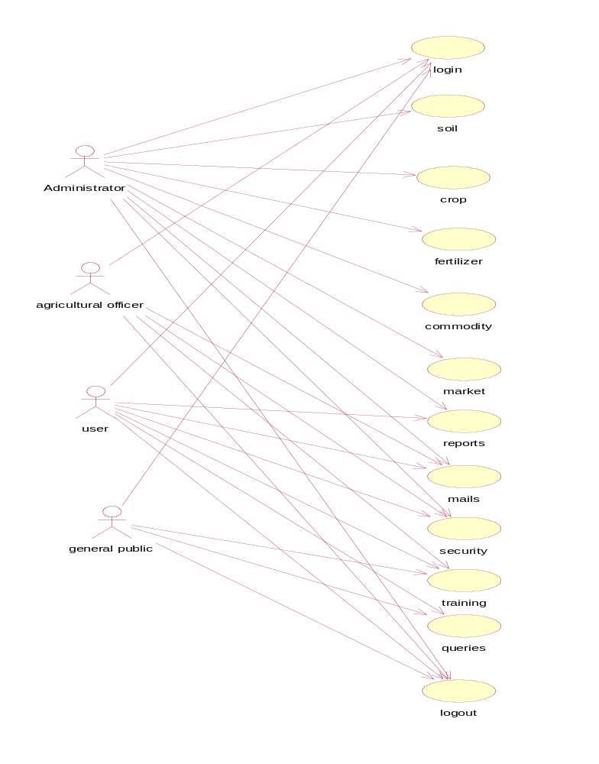
Figure 3: Use Case Diagram
6.2.2 Class Diagram:
A class diagram is an illustration of the relationships and source code dependencies among classes in the unified modeling language. In this context, a class defines the methods and variables in an object, which is a specific entity in a program or the unit of code representing that entity.
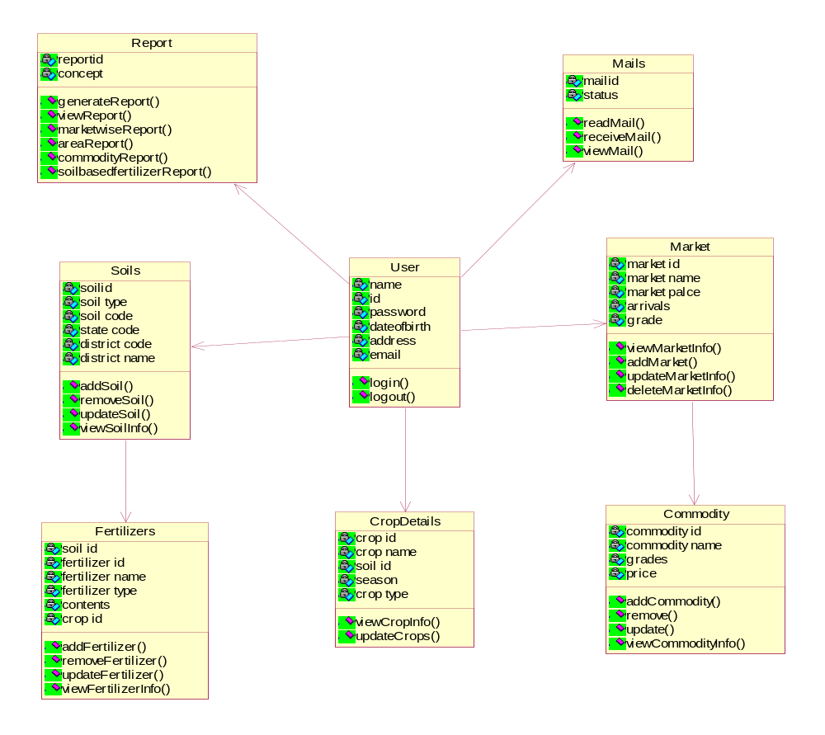

Figure 4: Class Diagram

    - Sequence Diagrams:
Sequence diagram is a diagram that shows object interactions arranged in time sequence. In particular it shows objects participating in the interaction and the sequence of messages exchanged.

1.Administrator:

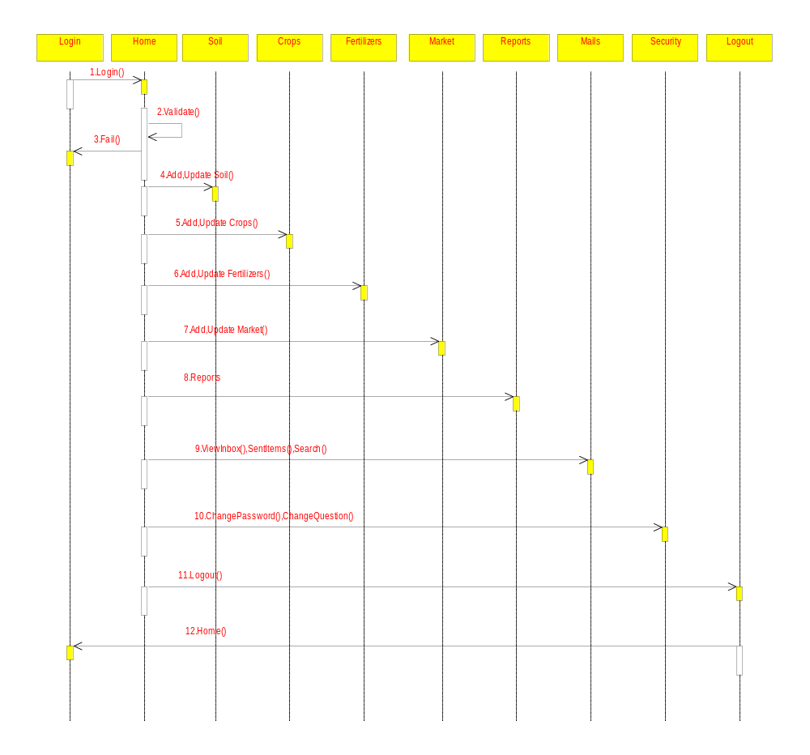

Figure 5.1: Sequence Diagram for administrator
2 . User:
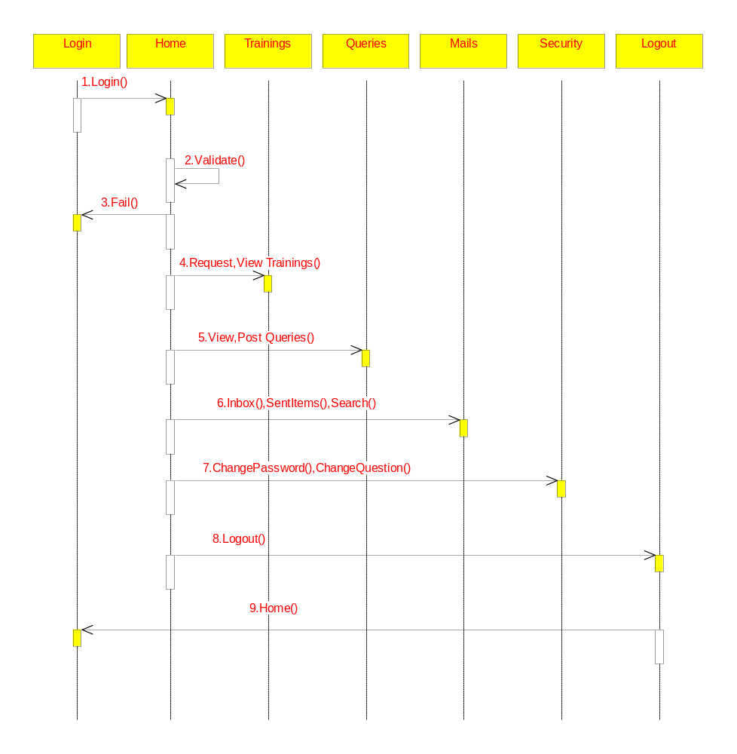
Figure 5.2: Sequence Diagram for user

3.Agricultural Officer:
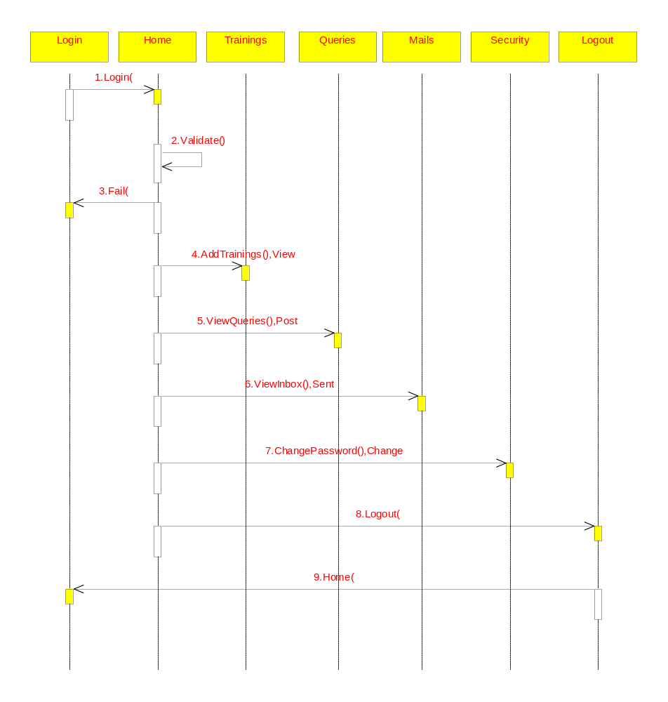
Figure 5.3: Sequence Diagram for agricultural officer

4.General Public:

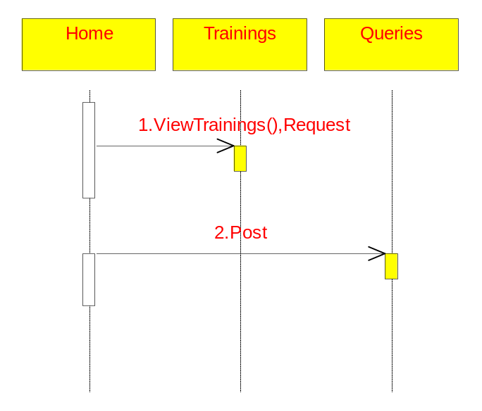
Figure 5.4: Sequence Diagram for general public

6.2.4 Collaboration Diagrams:
A collaboration diagram also called a communication diagram or interaction diagram is an illustration of the relationships and interactions among software objects in the unified modeling language.
1.Administrator
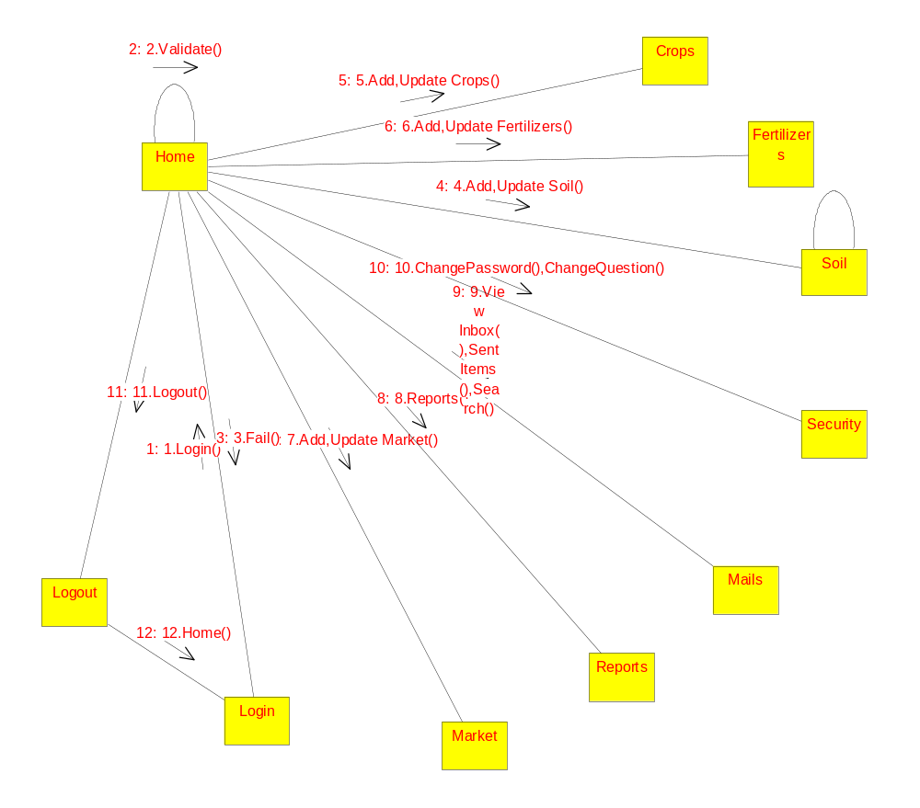

Figure 6.1: Collaboration Diagram for administrator

2.User

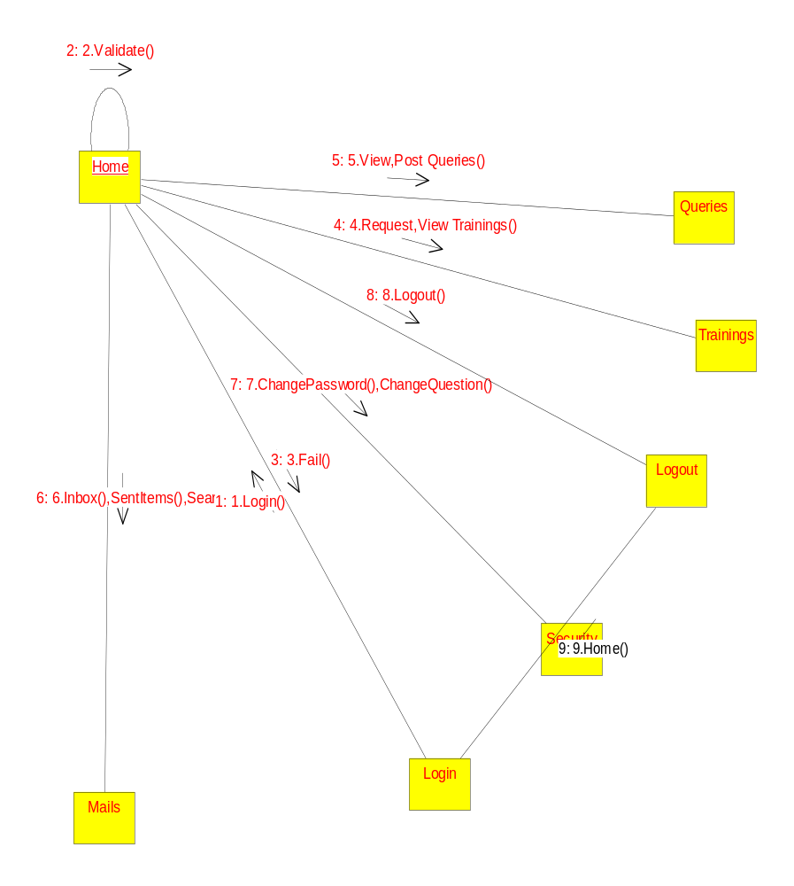

Figure 6.2: Collaboration Diagram for user

3.Agricultural Officer

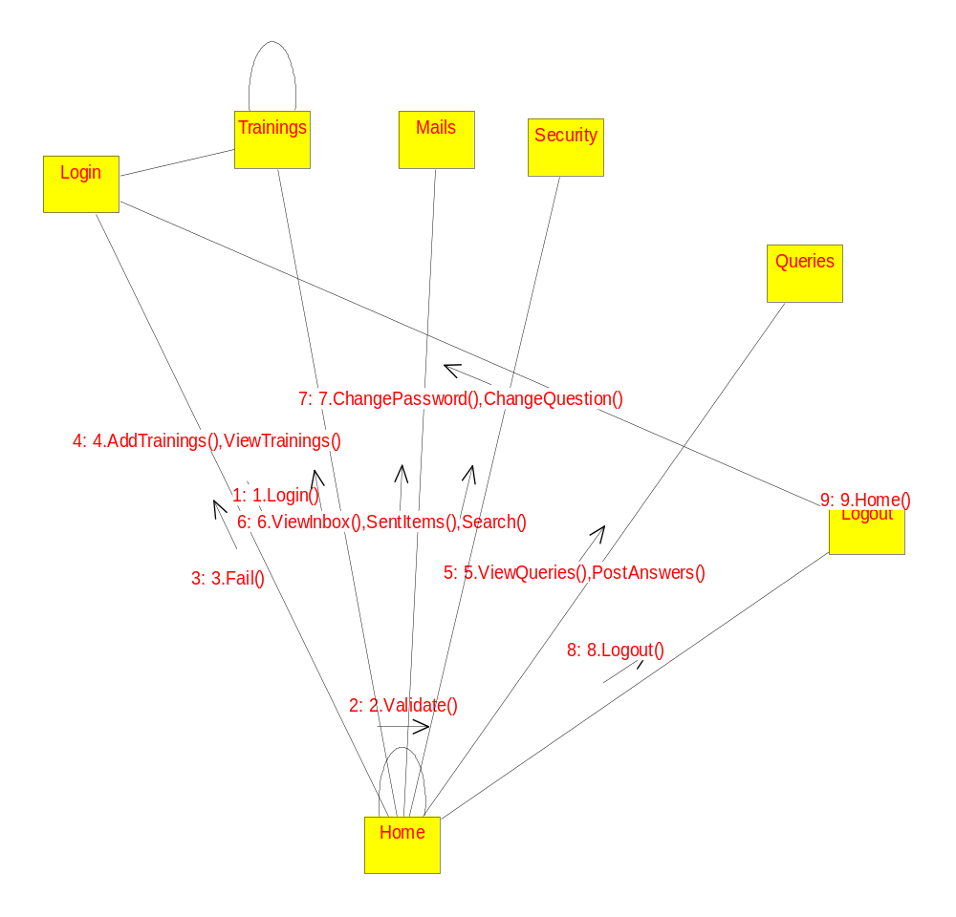

Figure 6.3: Collaboration Diagram for agricultural officer

4.General Public

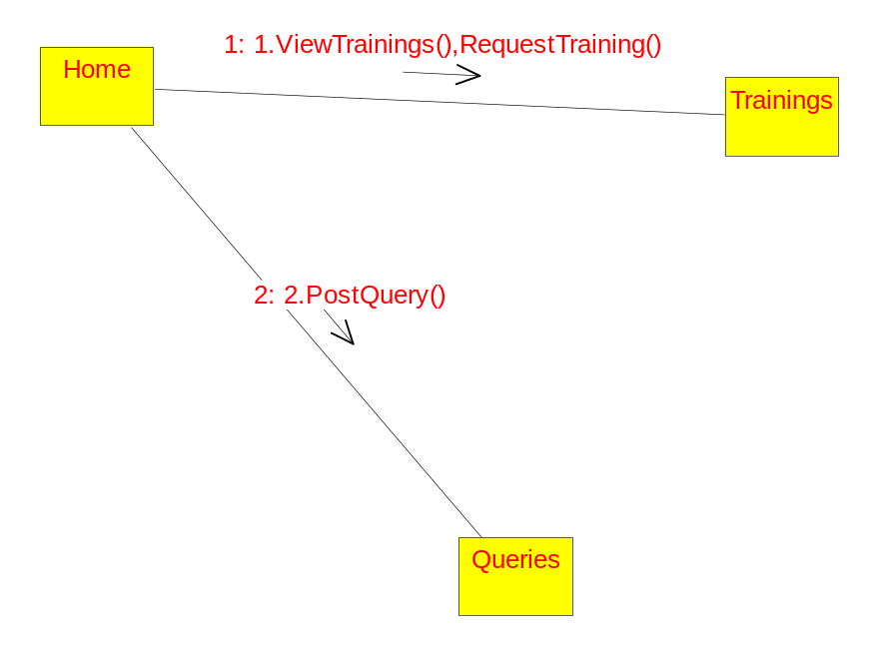
Figure 6.4: Collaboration Diagram for general public

    - Activity Diagrams:

Administrator:
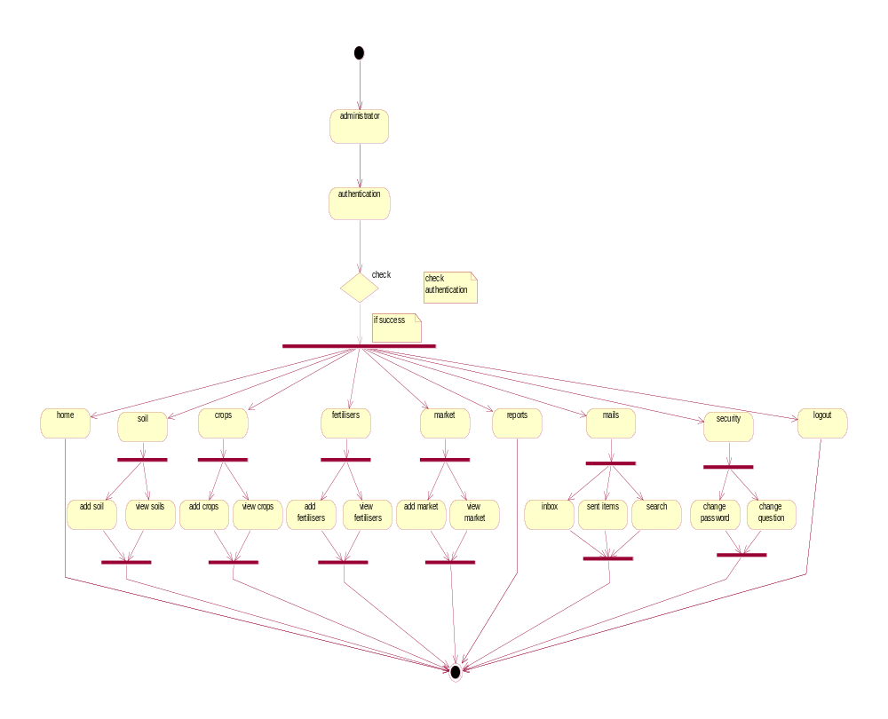

Figure 7.1: Activity Diagram for administrator

User:
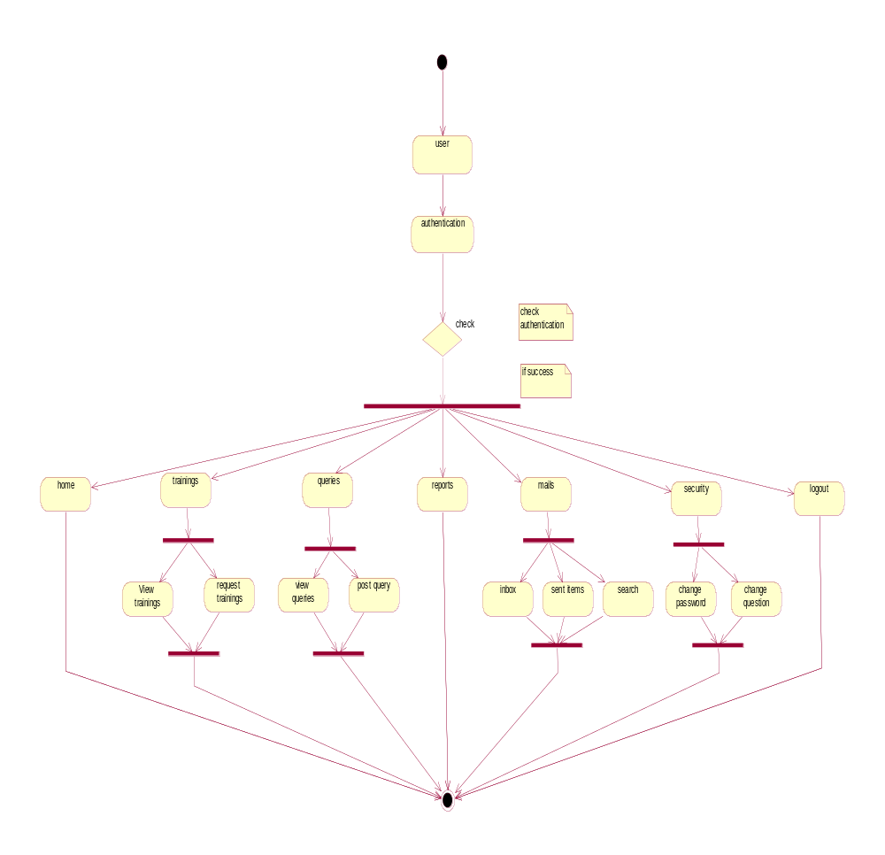
Figure 7.2: Activity Diagram for user

Agricultural Officer:
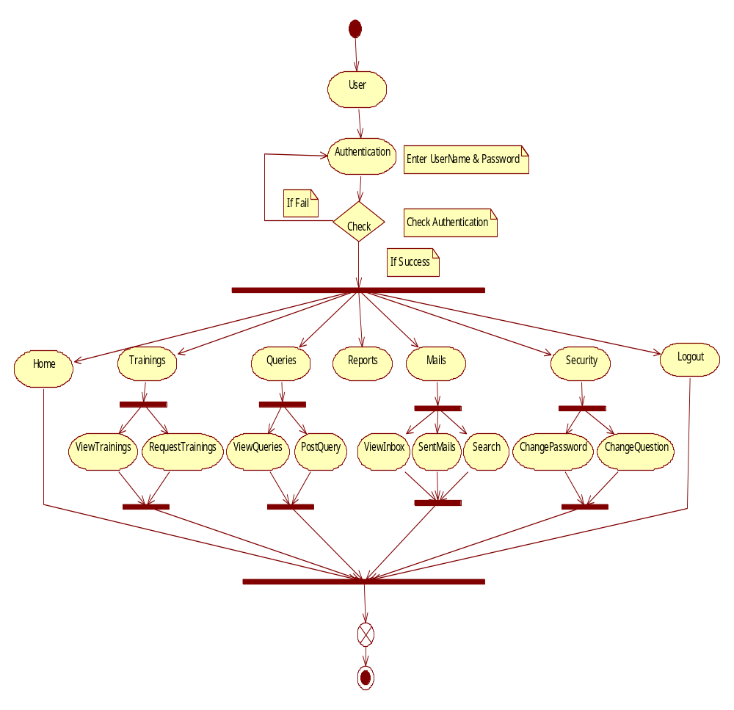

Figure 7.3: Activity Diagram for agricultural officer

6.2.6 Component Diagram:

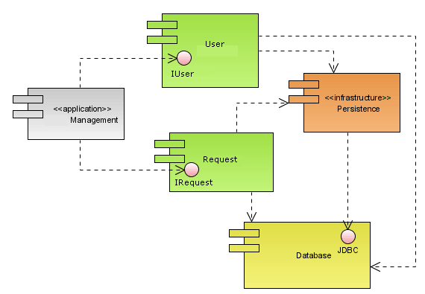

Figure 8: Component Diagram

6.2.7 Deployment Diagram:
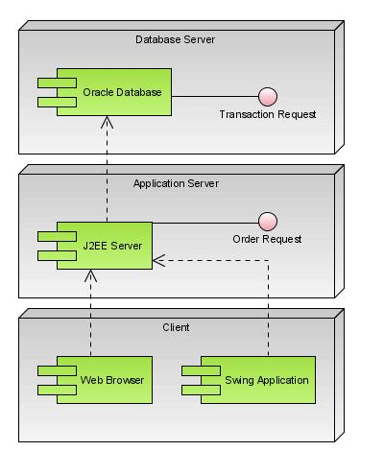

Figure 9: Deployment Diagram

6.3 System Specific Modules:
It has been modularized into following modules:
- User Module
- Soils and Fertilizers
- Crop Details
- Market Details
- Reports
- Mails

- User Module:
First, to enter this system the users has to login to this system. Basically there are 3 types of users in this system.
  - Admin users - Has full access to all the modules of this system.
  - Farmers and Agriculture Students – Has restricted access. i.e., Normal users have access to some of the modules only.
  - Agricultural officers: Has also restricted access.
- Soils and Fertilizers:
This module is used to maintain the various Soils and Fertilizers Details. This module will be enabled only to the admin type of users.
This module contains:
  - A separate screen should be provided to maintain the Soils and Fertilizers Details. It should provide a way to add, modify and delete the both details.
  - If a new Soil Information is received it should be added to the System.
  - If a new Fertilizer information is received it should be added to the system with the corresponding details like soil name, crop type, crop name etc.
3.Crop Details:
This module is used to maintain the various details about crops. This module will be enabled only to the admin type of users.
This module contains:
  - A separate screen should be provided to maintain the Crops Information. It should provide a way to add, modify and delete the crop details.
  - If a new crop information is received, it should be added to the system with the corresponding details like Soil Name, Crop Type, Crop Name and Season.
4.Market Details:
In this module we can maintain the market details. This module will be enabled only to the admin type of users.
This module contains:
- A separate screen should be provided to maintain the market related information. It should provide a way to add, modify and delete the market related information.
- Administrator type of user can add the commodities in the market.
- He can add the information about new markets into the system.
- He can add the market report into the system regarding a particular market and commodities prices details in that market in a day.
5.Reports
This module is used to prepare various online reports.
- Area Wise Crops report – This contains various information about the crops in a particular district.
- Soil Based Fertilizers report – This contains various information about the fertilizers based on the state, district, crop type and season.
- Commodity Wise report – This gives the different details about a particular commodity in a particular state and district.
- Market Wise Daily report – This gives the daily information about the various Markets in a particular state and district.
- Market Wise Monthly report – This report gives the market information in state and district in a particular month.

6.Mails:
This module provides the mail system to every user in the system who are authenticated.
- He can view the inbox to know about the emails he got.
- He can view the sent mails to know the mails he sent.
- He can send the mail to another user.

6.4 Screens

Step1: Login page validation:
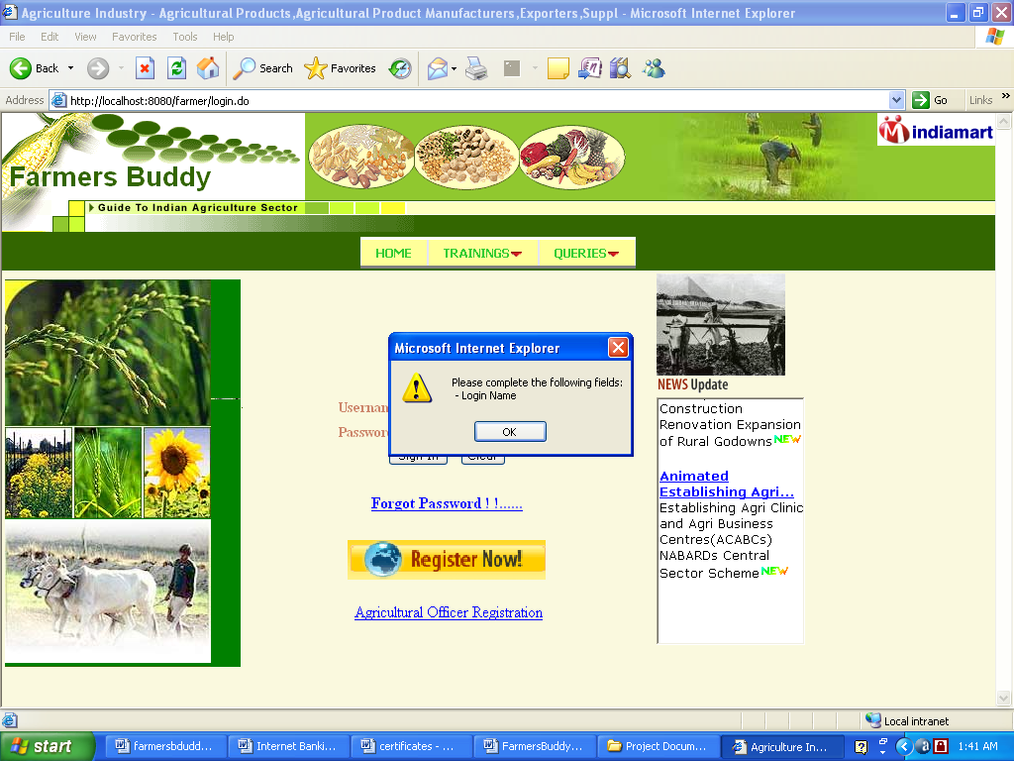

Step 2: Registration page:
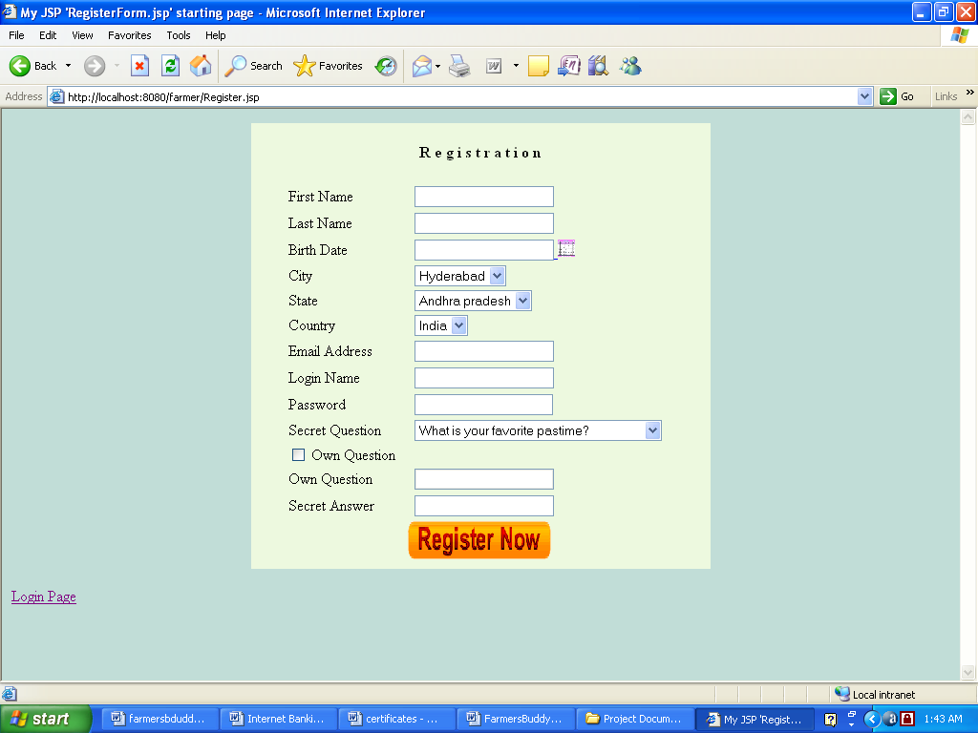

Step 3: Queries:
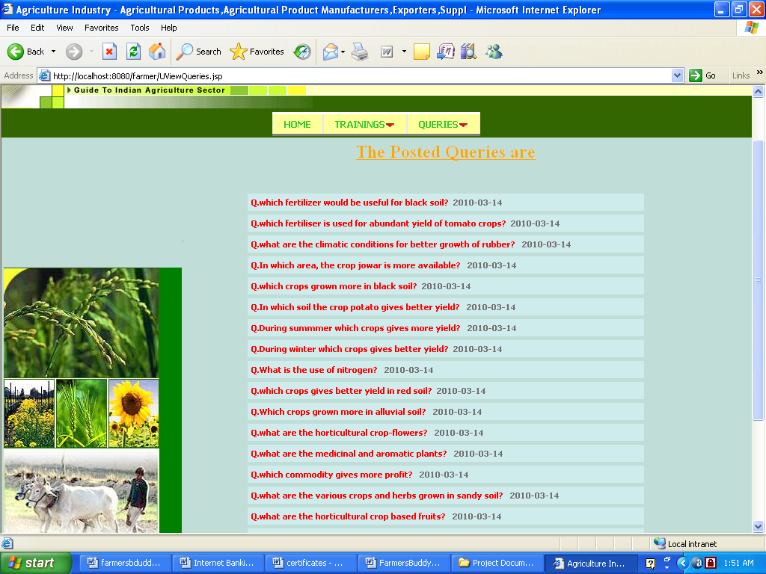

Step 4: Soil Entry Form:
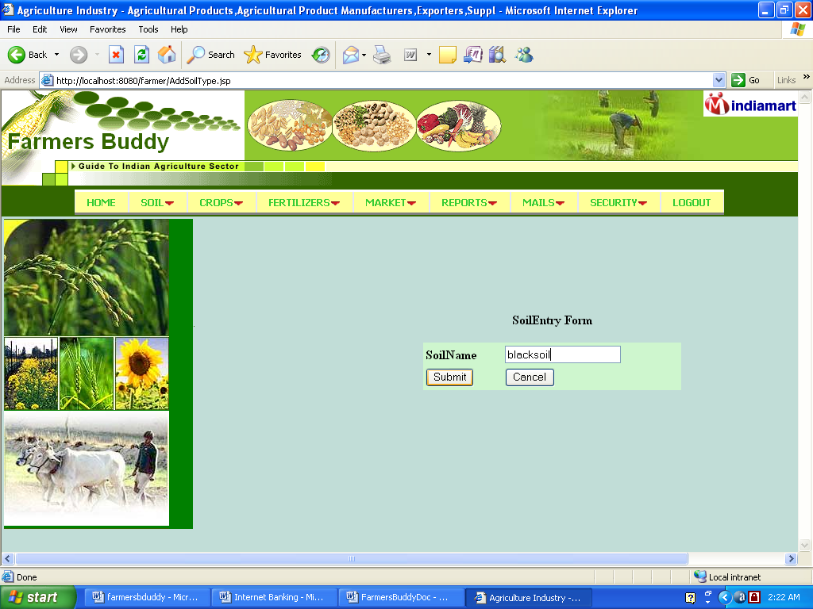

Step 5: District Information:
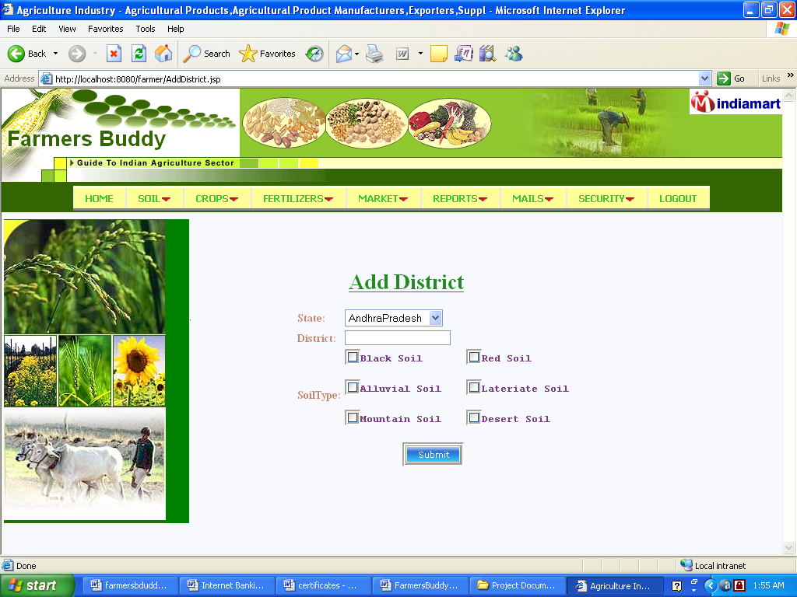

Step 6: Add Fertilizer Information:
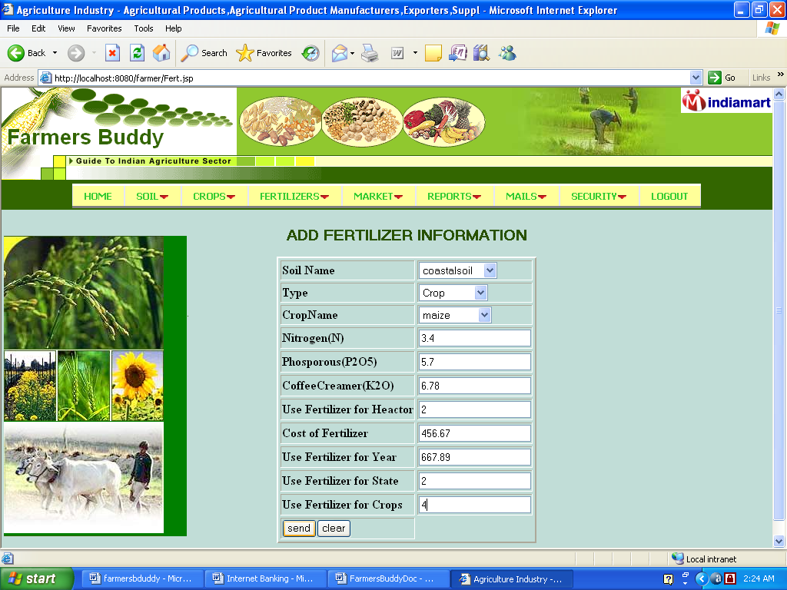

Step 7: Add market names:
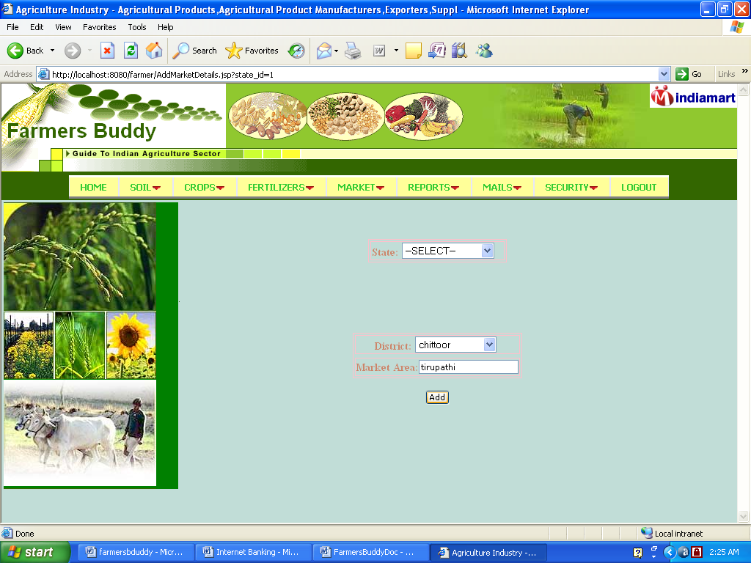

Step 8: Sent mails:
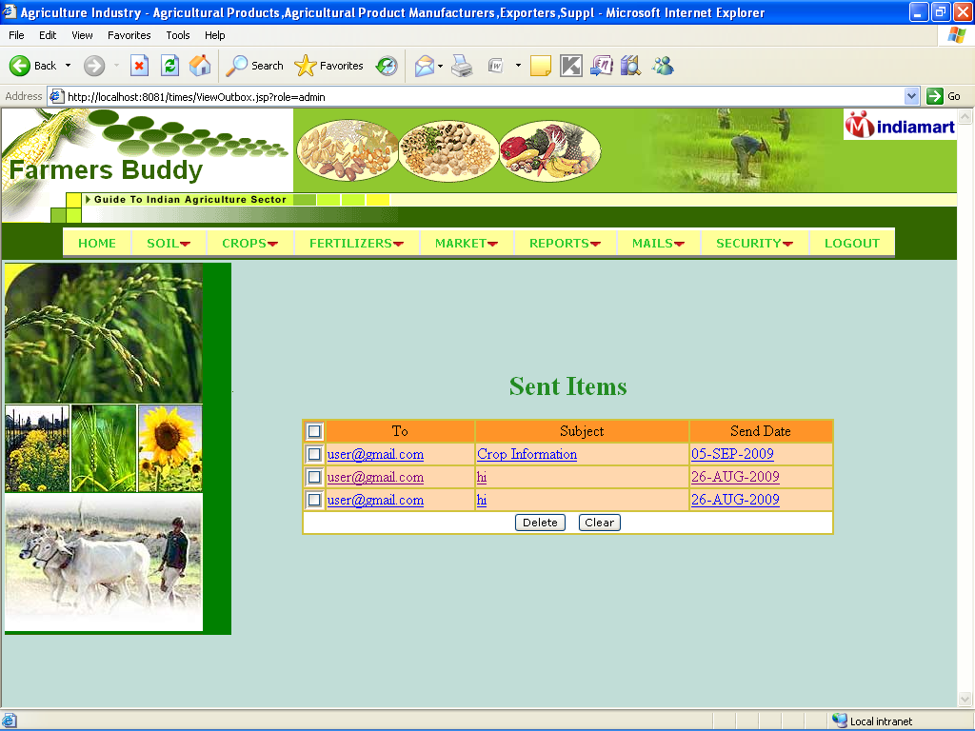

6.5 Source code
JSP:
LoginForm.jsp
<%@ page language="java" import="java.util.*" pageEncoding="ISO-8859-1"%>
<%String path = request.getContextPath();
String basePath = request.getScheme()+"://"+request.getServerName()+":"+request.getServerPort()+path+"/";
%>

<!DOCTYPE HTML PUBLIC "-//W3C//DTD HTML 4.01 Transitional//EN">
<html>
<head>
<base href="<%=basePath%>">
<title>My JSP 'LoginForm.jsp' starting page</title>
<meta http-equiv="pragma" content="no-cache">
<meta http-equiv="cache-control" content="no-cache">
<meta http-equiv="expires" content="0">
<meta http-equiv="keywords" content="keyword1,keyword2,keyword3">
<meta http-equiv="description" content="This is my page">
<!--
<link rel="stylesheet" type="text/css" href="styles.css">
-->
</head>

<body>
<form action="login.do" method="post" name="register">
<table width="200" border="0" align="center">
<tr>
<td><div align="center" class="style25">
<% if(request.getParameter("status")!=null) {%><strong><%=request.getParameter("status")%></strong>
<%}%>
</div></td>
</tr>
<tr>
<td><table width="314" height="206" border="0" align="center" bordercolor="#CD817E" bgcolor="#FAF9DE">
<tr>
<td width="1" height="57" valign="top"></td>
<td width="280"><div align="center" class="style24">L o g i n</div></td>
<td width="29"></td>
</tr>
<tr>
<td height="120" align="right"></td>
<td><table width="226" border="0" align="center">
<tr>
<td width="79"><span class="style23">Username</span></td>
<td width="189"><input type="text" name="username">
</td>
</tr>
<tr>
<td><span class="style23">Password</span></td>
<td><label>
<input type="password" name="password">
</label></td>
</tr>
<tr>
<td colspan="2"><label>
<div align="center">
<input type="submit" name="Submit" value="Sign In">
&nbsp;
<input name="Input2" type="reset" value="Clear">
</div>
</label></td>
</tr>
</table></td>
<td>&nbsp;</td>
</tr>
<tr>
<td height="21">&nbsp;</td>
<td valign="baseline">
<div align="center"><span class="style26"><a href="RecoverPassword.jsp">Forgot Password ! !......</a></span> <br>
<img src="images/regisbot.gif" alt="a" width="280" height="3"></div></td>
<td>&nbsp;</td>
</tr>
</table></td>
</tr>
</table>
<p align="center"><a href="Register.jsp"><img src="images/register.gif" width="250" height="50" border="0"></a>&nbsp;</p>
</form>
</body>
</html>

Register.jsp:
<%@ page language="java" import="java.util.*" pageEncoding="ISO-8859-1"%>
<%
String path = request.getContextPath();
String basePath = request.getScheme()+"://"+request.getServerName()+":"+request.getServerPort()+path+"/";
%>

<!DOCTYPE HTML PUBLIC "-//W3C//DTD HTML 4.01 Transitional//EN">
<html>
<head>
<base href="<%=basePath%>">
<title>My JSP 'RegisterForm.jsp' starting page</title>
<meta http-equiv="pragma" content="no-cache">
<meta http-equiv="cache-control" content="no-cache">
<meta http-equiv="expires" content="0">
<meta http-equiv="keywords" content="keyword1,keyword2,keyword3">
<meta http-equiv="description" content="This is my page">
<!--
<link rel="stylesheet" type="text/css" href="styles.css">
-->
<script type="text/javascript" src="scripts/ts_picker.js"></script>
<script language="javascript">
function check()
{
if(!document.register.ch.checked)
{
document.register.ownquest.disabled=true;
document.register.squest.disabled=false;
}
else
{
document.register.ownquest.disabled=false;
document.register.squest.disabled=true;
}
}
</script>
</head>
<body bgcolor="#c1DDD7">
<form name="register" action="register.do" method="post">
<%if(request.getParameter("status")!=null)
{%>
<%=request.getParameter("status")%>
<%}%>
<table width="481" border="0" align="center" bordercolor="#CD848F" bgcolor="#EDF9DF">
<tr>
<td width="7" height="57" valign="top">&nbsp;</td>
<td width="471"><div align="center"><span class="style11"><strong>R e g i s t r a t i o n</strong></span></div></td>
<td width="10">&nbsp;</td>
</tr>
<tr>
<td align="right">&nbsp;</td>
<td><table width="407" border="0" align="center">
<tr>
<td width="128"><span class="style17">First Name </span></td>
<td width="269"><label>
<input type="text" name="firstname">
</label></td>
</tr>
<tr>
<td><span class="style17">Last Name </span></td>
<td><label>
<input type="text" name="lastname">
</label></td>
</tr>
<tr>
<td><span class="style17">Birth Date </span></td>
<td><label>
<input type="text" name="bdate">
<a href="javascript:show_calendar('document.register.bdate', document.register.bdate.value);">
<img src="images/cal.gif" width="18" height="18" border="0"/></a>
</label></td>
</tr>
<tr>
<td><span class="style17">City</span></td>
<td><label>
<select name="city">
<option>Hyderabad</option>
<option>Mumbai</option>
</select>
</label></td>
</tr>
<tr>
<td><span class="style17">State</span></td>
<td><label>
<select name="state">
<option>Andhra pradesh</option>
<option>Maharashtra</option>
</select>
</label></td>
</tr>
<tr>
<td><span class="style17">Country</span></td>
<td><label>
<select name="country">
<option>India</option>
</select>
</label></td>
</tr>
<tr>
<td><span class="style17">Email Address</span></td>
<td><label>
<input type="text" name="email">
</label></td>
</tr>
<tr>
<td><span class="style17">Login Name </span></td>
<td><label>
<input type="text" name="loginname">
</label></td>
</tr>
<tr>
<td><span class="style17">Password</span></td>
<td><label>
<input name="password" type="password" id="password">
</label></td>
</tr>
<tr>
<td><span class="style17">
<label>Secret Question</label>
</span></td>
<td><select name="squest">
<option value="1">What is your favorite pastime?</option>
<option value="2">Who was your childhood hero?</option>
<option value="3">What was the name of your first school?</option>
<option value="4">Where did you meet your spouse?</option>
<option value="5">What is your favorite sports team?</option>
<option value="6">What is your father's middle name?</option>
<option value="7">What was your high school mascot?</option>
<option value="8">What make was your first car or bike?</option>
<option value="9">What is your pet's name?</option>
</select></td>
</tr>
<tr>
<td colspan="2"><span class="style17"> </span><span class="style18">
<label>
<input type="checkbox" name="ch" value="1" onClick="check()">
<span class="style20">Own Question</span> </label>
</span><span class="style17"> </span></td>
</tr>
<tr>
<td><span class="style17">Own Question </span></td>
<td><label>
<input type="text" name="ownquest" disabled>
</label></td>
</tr>
<tr>
<td><span class="style17">Secret Answer </span></td>
<td><input name="sanswer" type="text"></td>
</tr>
<input type="hidden" name="diff" value="user">
<tr>
<td colspan="2"><div align="center">
<INPUT type="image" name="submit" src="./images/RegisterNow.gif" border="0" style="border-width: 1px; height:40px; width:150px;" type="image">
</div></td>
</tr>
</table>
</td>
</tr>
</table>
</form>
</body>
</html>

6.6 System Evolution
Our system should provide services to the users who are existing in this system. Users should have valid user id and password to enter the system. The administrator, agricultural students, general public, agricultural officer can use the benefits of the system who are having valid user id and password.
System to be changed:
In the existing system periodic generation of reports takes lot of time. It is time consuming and lot of complications will arise. So there is necessity to change the system and then the time taking will be very short.
System understanding:
Complete understanding of the system that is to be done i.e. brief study of the requirements and designing of the system is to be developed.
System validation:
Validation can be find in many ways, but a simple definition is that validation succeeds when software functions in a manner that can be reasonably expected by the user, i.e. fulfilling all the user specified requirements.
Modified system:
Modified system provides periodic generation of reports which is not available for the existing system such that reduce work being done manually and time consumption.

7. Testing
7.1 Functional test cases:
Test case ID | Description | Test steps | Expected value | Actual value | OK/Error
1. | Verify login page | Input username and password | Login page | Invalid data | error
2 | Verify login page | Input username and password | Login page | Login page | ok
3. | Verify registration page | Registration | User profile | Registration failed | error
4. | Verify registration page | Registration | User profile | User profile | ok
5. | Query is to be posted | Posting query | Query is posted | Unable to post the query | error
6. | Query is to be posted | Posting query | Query is posted | Successfully posted | ok
7. | Soil name is to be entered | Enter soil name | Soil name is entered | Soil is entered | ok
8. | Crop name is to be entered | Enter crop name | Crop name is entered | Crop name is entered | ok
9. | Fertilizer information is to be entered | Enter fertilizer information | Fertilizer information is entered | Fertilizer information is entered | ok
10. | Commodity is to be entered | Enter commodity | Commodity is entered | Commodity is entered | ok
11. | Market details to be entered | Enter market details | Details of market is entered | Details of market is entered | ok
12. | Training information is to be entered | Enter training information | Information of training is entered | Information of training is entered | ok

7.2 Integration test cases:
Test case ID | Description | Test steps | Expected value | Actual value | OK/Error
1. | Verify that user should has correct user id and password to enter the system | - Invoke the browser  2. Entering the User ID and Password in login page  3. Click on trainings after entering the home page  4. Click on queries  5. click on soil  6. click on crops.  7. click on fertilizers  8. click on market details  9. click on mails | - page should be displayed with following fields:  a)username  b)password  c)sign in link  d)forgot password link  e) register now link  - Home page of the user will be displayed  - Add trainings and view trainings will be displayed  - View queries and post queries will be displayed  - Add soil , update soil,state information,district information will be displayed  - Add crop, update crops will be displayed  - Add fertilizers, update fertilizers, view fertilizers will be displayed  - Add markets,view markets,add commodities,view commodities will be displayed  - Inbox,sent mails,search will be displayed | 1. Page should be displayed with following fields:  a)username  b)password  c)sign in link  d)forgot password link  e) register now link  - Home page of the user will be displayed  - Add trainings and view trainings will be displayed  - View queries and post queries will be displayed  - Add soil , update soil,state information,district information will be displayed  - Add crop, update crops information will be displayed  - Add fertilizers, update fertilizers, view fertilizers will be displayed  - Add markets,view markets,add commodities,view commodities will be displayed  - Inbox,sent mails,search will be displayed | OK

7.3 System test cases:
Test case ID | Description | Test steps | Expected value | Actual value | OK/Error
1. | Verify that admin user should be able to generate the given functions. | 1. Invoke the browser  2. Entering the User ID and Password in login page  3. Click on trainings after entering the home page  4. Click on queries  5. click on soil  6. click on crops.  7. click on fertilizers  8. click on market details  9. click on mails | 1. page should be displayed with following fields:  a)username  b)password  c)sign in link  d)forgot password link  e) register now link  2. Home page of the user will be displayed  - Add trainings and view trainings will be displayed  - View queries and post queries will be displayed  - Add soil , update soil,state information,district information will be displayed  - Add crop, update crops will be displayed  - Add fertilizers, update fertilizers, view fertilizers will be displayed  - Add markets,view markets,add commodities,view commodities will be displayed  - Inbox,sent mails,search will be displayed | 1. Page should be displayed with following fields:  a)username  b)password  c)sign in link  d)forgot password link  e) register now link  - Home page of the user will be displayed  - Add trainings and view trainings will be displayed  - View queries and post queries will be displayed  - Add soil , update soil,state information,district information will be displayed  - Add crop, update crops information will be displayed  - Add fertilizers, update fertilizers, view fertilizers will be displayed  - Add markets,view markets,add commodities,view commodities will be displayed  - Inbox,sent mails,search will be displayed | OK

8.Conclusion

By this project, we provide various information required for farmers and agricultural students and also providing solutions to them about queries posted by them. This makes agriculture more ecofriendly and this portal is very useful to farmers and agricultural students.

9. Appendix A - Hardware and Software Configurations

HARDWARE REQUIREMENTS:
Processor : Pentium IV
Hard Disk : 40GB
RAM : 512MB or more

SOFTWARE REQUIREMENTS:
Operating System : Windows XP/2003 or Linux
User Interface : HTML, CSS
Client-side Scripting : JavaScript
Programming Language : Java
Web Applications : JDBC, Servlets, JSP
Database : Oracle 10g
Server Deployment : Tomcat 5.0

10. Appendix B – Data Base Tables
Loginprofile:
Name | Constraint | Datatype
Loginid | Primary key | Varchar2(40)
birthdate |  | Date
City |  | Varchar2(40)
State |  | Varchar2(40)
Country |  | Varchar2(40)
Profilemodification |  | Date
email |  | Varchar2(25)
qualification |  | Varchar2(30)
designation |  | Varchar2(30)

LoginDetails:
Name | Constraint | Datatype
Loginname | Primary key | Varchar2(30)
Password |  | Varchar2(30)
Logintype |  | Varchar2(20)
First_name |  | Varchar2(40)
Last_name |  | Varchar2(40)
Login_status |  | number
Reg_date |  | Date
Squestionid | Primary key | number
sanswer |  | Varchar2(40)
Passmodified |  | Date
firstlogin |  | number

Commodity:
Name | Constraint | Datatype
Cmid | Primary key | number
cname |  | Varchar2(35)

Fert_info:
Name | Constraint | Datatype
Soil_id |  | number
Nitrogen |  | number
Phosphor |  | number
Coffeecreamer |  | number
Usefertacre |  | number
Costfert |  | number
Usefertyear |  | number
Usefertstate |  | number
Cvherb1 |  | Varchar2(20)
Cropsname |  | Varchar2(30)
Soil_name |  | Varchar2(20)

Login_audit:
Name | Constraint | Datatype
Loginid | Foreign key | Varchar2(40)
Logindate |  | Date
Login_desc |  | Varchar2(40)

Mails:
Name | Constraint | Datatype
Messageid |  | number
Fromname |  | Varchar2(20)
Toname |  | Varchar2(20)
senddate |  | date
subject |  | Varchar2(30)
message |  | Varchar2(100)
Senderstatus |  | Number
receiverstatus |  | number

Market_details:
Name | Constraint | Datatype
State_code | Foreign key | number
Dist_code | Foreign key | number
Marketid | Foreign key | number
market |  | Varchar2(30)

Market_report:
Name | Constraint | Datatype
Market | Primary key | number
Arrivals |  | number
Arrival_dt |  | date
Unit of arrival |  | Varchar2(20)
Variety | Foreign key | number
grade |  | Varchar2(20)
Minprice |  | number
Maxprice |  | number
Modalprice |  | number
Unitprice |  | Varchar2(30)
Id |  | number

Query:
Name | Constraint | Datatype
Queryid |  | number
Query |  | Varchar2(150)
Postedby |  | Varchar2(20)
Pstdate |  | date
answer |  | Varchar2(200)
ansby | Primary key | Varchar2(30)
Status |  | Varchar2(10)

Question_base:
Name | Constraint | Datatype
Question_id | Foreign key | number
Question_description |  | Varchar2(70)

Sb_crops:
Name | Constraint | Datatype
Soil_code | Foreign key | number
Soil_name |  | Varchar2(40)
Cropname |  | Varchar2(20)
Season |  | Varchar2(20)
cvherb |  | Varchar2(20)

Soil_ident:
Name | Constraint | Datatype
Soil_code | Primary key | number
Soil_name |  | Varchar2(40)

Soil_type:
Name | Constraint | Datatype
State_code | Foreign key | number
Soil_code | Foreign key | Varchar2(40)
Dist_code | Primary key | number
Dist_name |  | Varchar2(40)

State_info:
Name | Constraint | Datatype
State_code | Primary key | number
State |  | Varchar2(40)
Wcondition |  | Varchar2(200)

Traing_info:
Name | Constraint | Datatype
Traing_id |  | number
Title | Foreign key | Varchar2(40)
Description |  | Varchar2(200)
Schedule |  | Varchar2(20)
status |  | Varchar2(20)

Training_request:
Name | Constraint | Datatype
Req_id |  | number
Name |  | Varchar2(20)
Role |  | Varchar2(20)
Place |  | Varchar2(20)
title | Primary key | Varchar2(20)
description |  | Varchar2(20)
Reqschedule |  | Varchar2(20)

11. Appendix C- Limitations And Enhancements
Limitations:
- It is open discussion forum so that everyone uploads unwanted and wrong information so that it misleads the students and farmers.
- Quite inefficiency in querying details.
Enhancements:
It is not possible to develop a system that makes all the requirements of the user. User requirements keep changing as the system is being used. Some of the future enhancements that can be done to this system are:
- As the technology emerges, it is possible to upgrade the system and can be adaptable to desired environment.
- Because it is based on object-oriented design, any further changes can be easily adaptable.
- Based on the future security issues, security can be improved using emerging technologies.
- Case Registration module can be added

12. Appendix D-Bibliography:

References:
(1) Java Complete Reference by Herbert Schildt
(2) Database Programming with JDBC and Java By George Reese
(3) Java and XML By Brett McLaughlin

(4) Wikipedia, URL: http://www.wikipedia.org.

(5) Answers.com, Online Dictionary, Encyclopedia and much more, URL: http://www.answers.com
(6) Project Management URL: http://www.startwright.com/project.htm

